Implementation of a HeapReport Issue
We often perform insertion, deletion, and getting the top element with a Heap data structure.
We can implement a Heap using an array. Elements in the Heap can be stored in the array in the form of a binary tree. The code below will implement “Max Heap” and “Min Heap” for integers (In LeetCode problems or daily work, we often will use existing libraries instead of manually implementing Heap).

Min Heap:

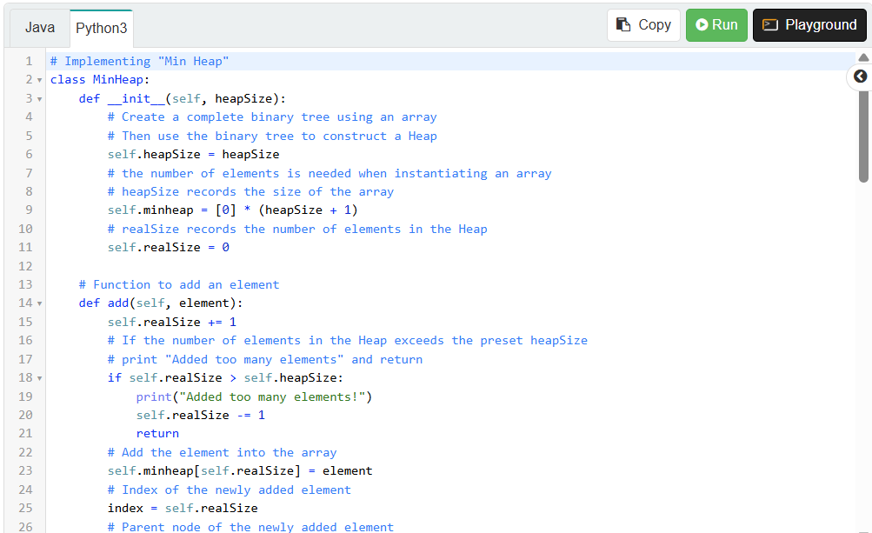

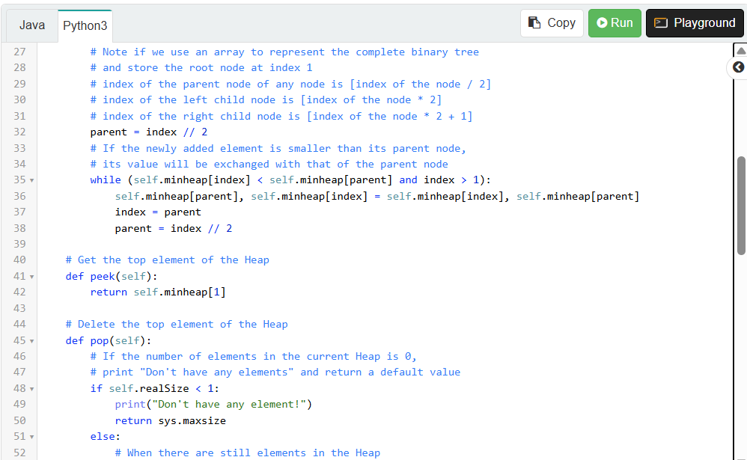

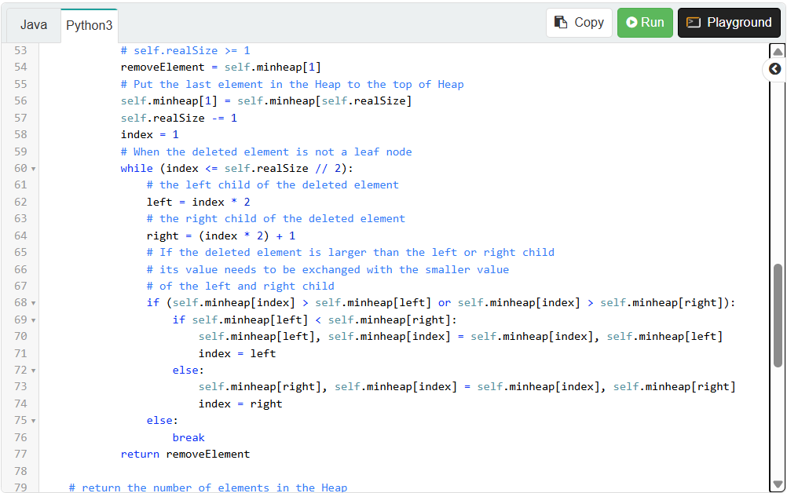

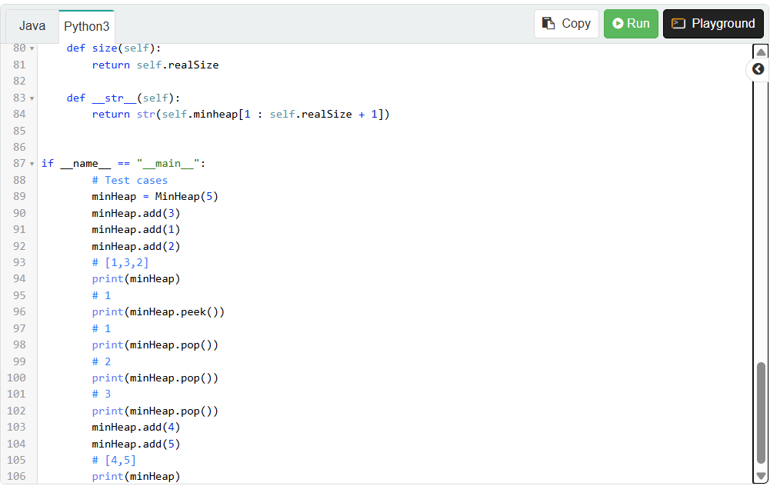

Max Heap:

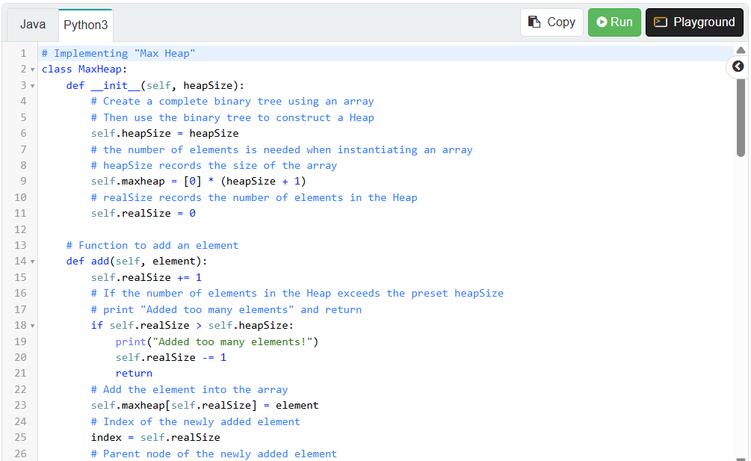

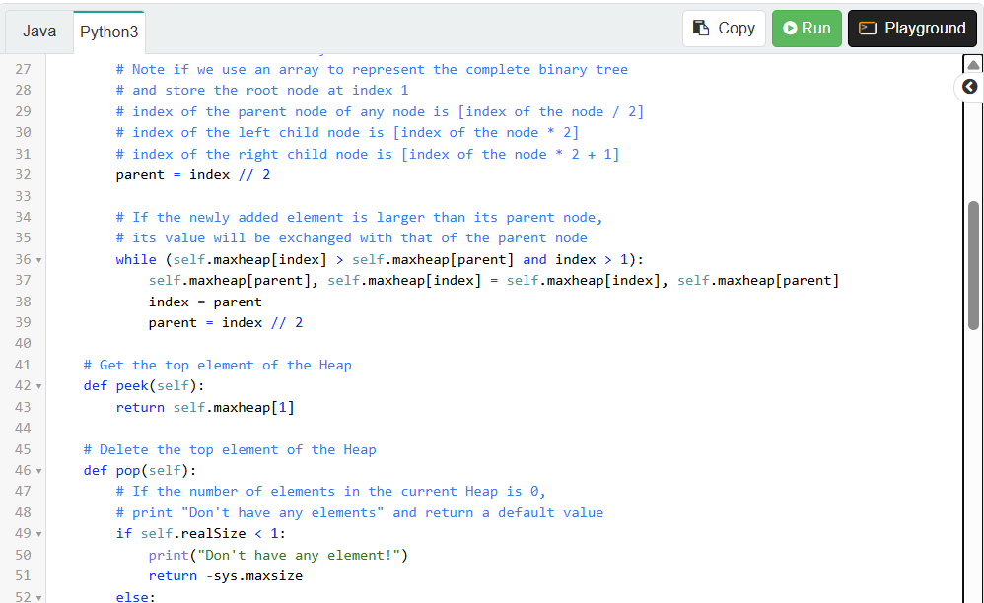

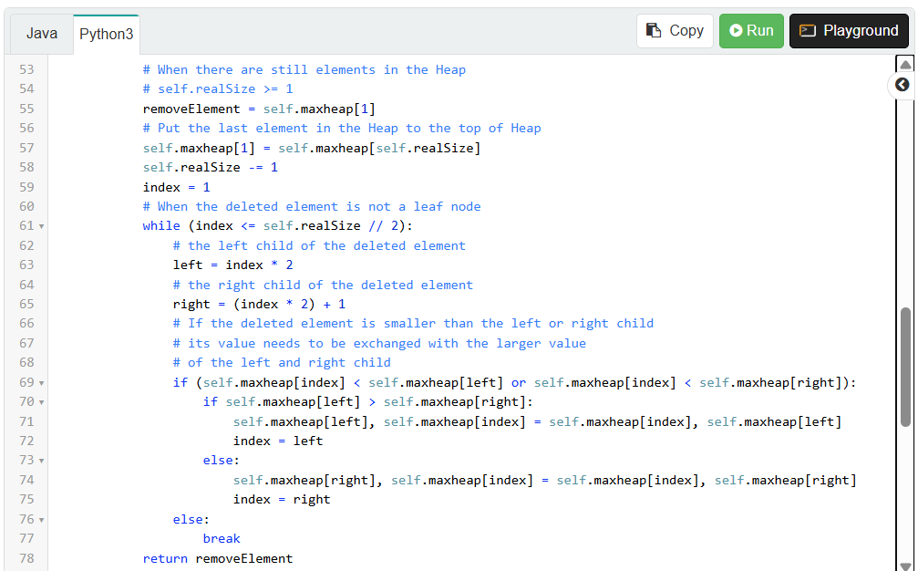

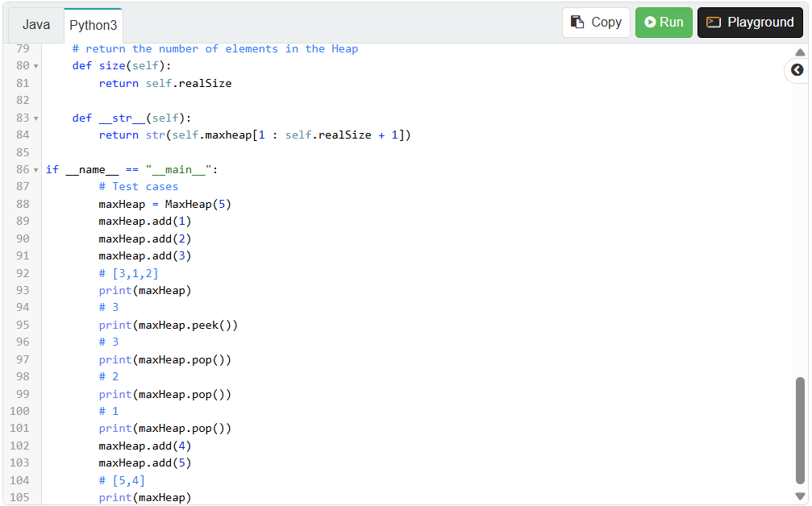

Complete Tree to Array Video
In the following video we will learn how to transform a binary tree into an array. During this process, we will discuss how to store a binary tree in an array, how to find the children/parents of a node when the tree is stored in an array, and how to determine if a node is a leaf node.
